**15**

**Oscillatory Motion**

|  |
| --- |
| **CHAPTER OUTLINE** |

15.1 Motion of an Object Attached to a Spring

15.2 Analysis Model: Particle in Simple Harmonic Motion

15.3 Energy of the Simple Harmonic Oscillator

15.4 Comparing Simple Harmonic Motion with Uniform Circular Motion

15.5 The Pendulum

15.6 Damped Oscillations

15.7 Forced Oscillations

\* An asterisk indicates a question or problem new to this edition.

|  |
| --- |
| **SOLUTIONS TO THINK-PAIR-SHARE AND ACTIVITIES** |

**\*TP15.1 Conceptualize** When the balls collide, the portion of each ball next to the other one compresses until the balls stop momentarily. They then rebound and move off in opposite directions. The problem compares two models for what happens as the balls compress.

**Categorize** Group (i) will model each ball as an *isolated system* for *energy* (because the point of application of the force from the other ball is fixed in space: no work is done), and the center of mass of each ball as a *particle under constant acceleration*. Group (ii) will model the center of mass of each ball as a *particle in simple harmonic motion.*

**Analyze** (a) Let’s look first at the calculation of the spring constant of the ball from the information about the ball in the vise, which both groups can use. From Hooke’s law:

 (1)

where we will use the magnitudes of *F* and *s* as given in the problem statement.

From here on, the procedures of the groups diverge.

*Group (i):* Modeling each ball as an isolated system for energy, we can find the distance *x* by which each ball is compressed in the collision by using the appropriate reduction of Equation 8.2 for one ball:

 (2)

Now, from the particle under constant acceleration model, use Equation 2.15 to find the time at which the ball comes momentarily to rest:

 (3)

This is the time at which the ball comes to rest, so it represents half of the total time interval during which the balls are in contact, which is

 (4)

Substitute Equation (2) into Equation (4) and then use Equation (1) to substitute for *k*:

 (5)

Substitute numerical values:



*Group (ii):* Modeling the center of mass of each ball as a particle in simple harmonic motion, we see that, during the time of contact, the ball goes through half a cycle of its oscillation and then the balls separate. Therefore, the time interval during which the balls are in contact is half the period of the oscillation, which can be found from Equation 15.13:

 (6)

Substitute Equation (1):

 (7)

Substitute numerical values:



(b) The results in both parts of the problem are on the order of 10–4 s, but differ by about 27%. If we are going to model the compressed ball as a spring, as we did from the vise information, then Group (ii)’s result is more accurate. The acceleration of the ball is not constant as in Group (i)’s calculation, but varies with position, which is taken into account in the model used by Group (ii). Compare Equations (5) and (7). The only difference in the results is the factor in front of the square root, 4 for Group (i) and ** for Group (ii).

**Finalize** One thing that might be surprising is that neither calculation depends on the speed of the balls! Therefore, the balls are in contact for the same time interval regardless of how fast they are going. See if you can justify that conceptually in your mind.

Answers:(a) Group (i): 1.16 × 10–4 s; Group (ii): 9.12 × 10–5 s (b) Group (ii)

**\*TP15.2 Conceptualize** Notice the similarities between the two situations. The distances by which the springs stretch are only slightly different when objects of similar mass are hung from them. Both objects are pulled down by the same distance and then both are released from rest.

**Categorize** Each of the two objects is modeled as a *particle in simple harmonic motion.*

**Analyze** (a) First find the angular frequency of each of the systems, using Equation 15.9, where the force constant *k* is equal to the mass *mg* hung on the spring divided by the resulting extension  of the spring:

 (1)

Substitute numerical values:



where we have kept several significant figures and will round at the end of the calculation. Notice that these frequencies are quite close to each other.

(1) Now evaluate the position of each object using Equation 15.6, , noting that each object begins at position *x* = –0.180 m, so that ** = –**:



(2) The number of cycles through which each oscillator has vibrated can be found by dividing the total time interval of vibration by the period:

 (2)

In each cycle, the object moves through a distance 4*A*, so the total distance traveled is

 (3)

Now evaluate the distance traveled by each object:



(b) Notice that the initial data are similar for the two oscillators, and the distances traveled by the oscillators in calculation (2) are similar. But the final positions of the oscillators in calculation (1) are very different: one is well above the equilibrium position and the other is well below. There is a small difference in the oscillation frequency, resulting in a difference in final position that grows with each new cycle of oscillation until we see the situation in calculation (1).

(c) Yes, it does represent a difficulty in predicting the future based on systems that oscillate. While the difference between the positions grows with each new cycle for the first few after the beginning, the difference does not grow forever because the system is cyclical. For example, let’s look at 169.21 s. At that time,



Both oscillators are at the exact same position! In fact, this is the first time after release that they are at the same position. In general, then, for a pair of oscillating systems with slightly different parameters, the relationship between them will depend on when we happen to take the measurement. At some times the systems may have measurements that are very close, at other times, very different.

**Finalize** One final thing to notice: we never used the values of the masses of the two objects! Is that a surprise? This is yet another demonstration of why we come up with algebraic solutions first before substituting numerical values: in Equation (1) the mass cancels and we never need to use it. If we had found the spring constant *k* numerically first and then found the angular frequency ** numerically from that, we would have substituted the mass twice, when it isn’t even necessary if we solve algebraically.

Answers: (a) (i) (1) *x* = –15.8 cm (2) *d* = 51.2 m; (ii) (1) *x* = 15.9 cm (2) *d* = 50.8 m (b) Answers will vary. (c) Answers will vary

**\*TP15.3 Conceptualize** As the length decreases, the period should also decrease, according to Equation 15.26. We do indeed see this happening in the data.

**Categorize** We model the pendulum as a *simple harmonic oscillator* for small oscillations, leading to Equation 15.26.

**Analyze**  Both groups will need to use the period of the oscillations, which can be found by dividing the time interval in the table by 50:

|  |  |  |
| --- | --- | --- |
| **Length *L* (m)** | **Time interval for  50 oscillations (s)** | **Period *T* (s)** |
| 1.000 | 99.8 | 1.996 |
| 0.750 | 86.6 | 1.732 |
| 0.500 | 71.1 | 1.422 |

From here on, the procedures of the groups diverge.

*Group (i):* Solve Equation 15.26 for the value of *g*:

 (1)

Use Equation (1) to find a value for *g* for each of the three data points:

|  |  |  |  |
| --- | --- | --- | --- |
| **Length *L* (m)** | **Time interval for 50 oscillations (s)** | **Period *T* (s)** | ***g* (m/s2)** |
| 1.000 | 99.8 | 1.996 | 9.91 |
| 0.750 | 86.6 | 1.732 | 9.87 |
| 0.500 | 71.1 | 1.422 | 9.76 |

Now find the mean value of these three values:

 (2)

*Group (ii):* This group will need the values for the squares of the period:

|  |  |  |  |
| --- | --- | --- | --- |
| **Length *L* (m)** | **Time interval for 50 oscillations (s)** | **Period *T* (s)** | ***T*2 (s2)** |
| 1.000 | 99.8 | 1.996 | 3.984 |
| 0.750 | 86.6 | 1.732 | 3.000 |
| 0.500 | 71.1 | 1.422 | 2.022 |

Now, graph the square of the period versus the length of the pendulum:

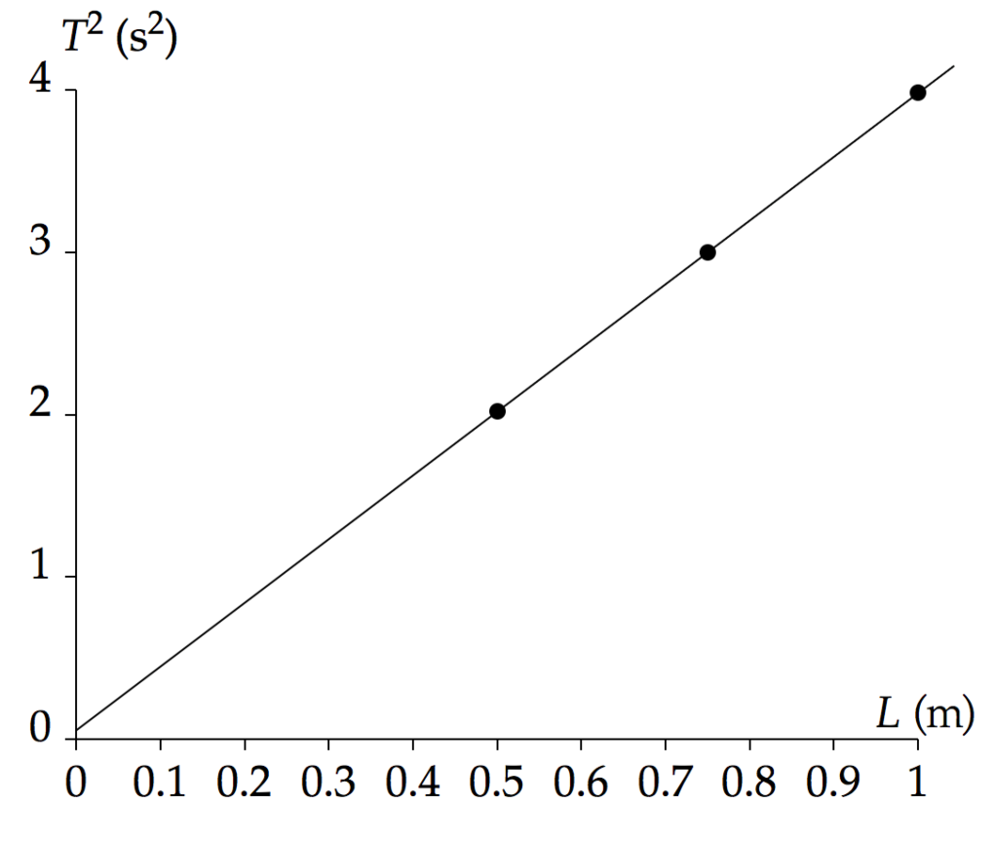

A least-squares fit shows the slope of the line is 3.924 s2/m. Rearranging Equation (1), we see that

 (2)

Therefore, we recognize the slope of a graph of *T*2 versus *L* to be

 (3)

which leads to

 (4)

Substitute the value of the slope from the graph:

 (5)

**Finalize** Let’s look at how each value differs from the true value.

Group (i):

*g*avg = 9.85 m/s2 is 0.55% higher than the true value of 9.80 m/s2

Group (ii):

*g* = 10.1 m/s2 is 3.1% higher than the true value of 9.80 m/s2

For this particular data set, the graphing method gave a value that was farther from the true value of *g* than that obtained by averaging the values of *g* for each data point. This is the opposite of what would happen in general, and reflects the fact that we only have three data points. In an experiment with more data points, the graphing method should give a more accurate value than the method used by Group (i).

Answers: Group (i): 9.85 m/s2; Group (ii): 10.1 m/s2

|  |
| --- |
| **SOLUTIONS TO END-OF-CHAPTER PROBLEMS** |

**Section 15.1 Motion of an Object Attached to a Spring**

**P15.1** (a) Taking to the right as positive, the spring force acting on the block at the instant of release is



(b) At this instant, the acceleration is



or 

**Section 15.2 Analysis Model: Particle in Simple Harmonic Motion**

**P15.2** From the information given, we write the equation for position as  with the amplitude given as *A* = 0.050 0 m. Differentiating gives us the piston’s velocity,



and differentiating again gives its acceleration



Then, if *f* = 3600 rev/min = 60 Hz, then 

(a) 

(b) 

**P15.3**  compare this with  to find

(a)  or 

(b) 

(c) 

(d) 

(e) 

**P15.4** An object hanging from a vertical spring moves with simple harmonic motion just like an object moving without friction attached to a horizontal spring. We are given the period, which is related to the frequency of motion by *T* = 1/*f*. Then, since 



Solving for *k*,



**P15.5** (a) For constant acceleration position is given as a function of time by



(b) 

**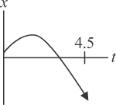**

ANS. FIG.15.5(a, b)

(c) For simple harmonic motion we have instead



and 

where  so that  

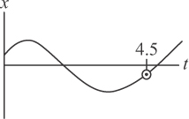

ANS. FIG. P15.5(c, d)

At *t* = 0,  and 

Dividing gives    Still at *t* = 0,  *A* = 0.299 m.

Now at *t* = 4.50 s,



(d) 

**P15.6** (a) Since the collision is perfectly elastic, the ball will rebound to the height of 4.00 m and then repeat the motion over and over again. Thus, the 

(b) To determine the period, we use  The time for the ball to hit the ground is

 

This equals one-half the period, so .

(c) 

**P15.7** The period of the oscillation is 

(a) At *t* = 0, *x* = 0 and *v* is positive (to the right). Therefore, this situation corresponds to  and  Since   
*f* = 1.50 Hz,  and *A* = 2.00 cm: 

where *x* is in centimenters and *t* is in seconds.

(b) 

(c) The particle has this speed at *t* = 0 and next after half a period:



(d) 

(e) This positive value of maximum acceleration first occurs when the particle is reversing its direction on the negative *x* axis, three-quarters of a period after *t* = 0: at .

(f) Since  and *A* = 2.00 cm, the particle will travel 8.00 cm in one cycle. Hence, in  cycles, the particle will travel .

**P15.8** The proposed solution,



implies velocity



and acceleration



(a) The acceleration being a negative constant times position means we do have SHM, and its angular frequency is ** At *t* = 0 the equations reduce to  and  so they satisfy all the requirements.

(b) 

So the expression  is constant in time because all the parameters in the final equivalent expression  are constant. Because  must have the same value at all times, it must be equal to the value at *t* = 0, so  If we evaluate  at a turning point where *v* = 0 and *x* = *A*, it is  Thus it is proved.

**P15.9** (a) 

(b) We assume that the mass of the spring is negligible and that we are on Earth. Let *m* represent the mass of the object. Its hanging at rest is described by

 where *x* = 18.3 cm

To find the period, we must find the angular frequency  We do not know the mass, but we do not need it because



From our value for *x*, we find





**Section 15.3 Energy of the Simple Harmonic Oscillator**

**P15.10** Choose the car with its shock-absorbing bumper as the system; by conservation of energy,



**P15.11** Model the oscillator as a block-spring system. From energy considerations,



with  and  so



From this we find



and since *A* = 3.00 cm,



**P15.12** (a)  so if  

Therefore 

(b) , so if *A* is doubled, 

(c) , so if *A* is doubled, 

(d) is independent of *A*, so 

**P15.13** (a) Energy is conserved by an isolated simple harmonic oscillator:



When *x* = *A*/3,



(b) When *x* = *A*/3,



(c) 



(d)  The maximum potential energy of the system is equal to the total energy of the system: kinetic plus potential energy. Because the total energy must remain constant, the kinetic energy can never be greater than the maximum potential energy.

**P15.14** (a) 

(b) 



(c) The system of the bungee jumper, the spring (cord), and the Earth is 

(d) The system is isolated, so energy is conserved within the system. Take the initial point where she steps off the bridge and the final point at the bottom of her motion.



which gives 

(e) The spring extension at equilibrium is



so this point is  and the amplitude of her oscillation is 36.0 m – 19.7 m = 16.3 m.

(f) 

(g) Set *x* = 0 at the equilibrium position of the bungee jumper on the spring. Relative to the equilibrium position, the lowest part of the drop corresponds to *x* = +16.3 m—we have taken down as positive—and the point in the drop where the spring begins to stretch is at *x* = –8.68 m. Take the phase as zero at maximum downward extension (*x* = +16.3 m). We find that the phase,  was 25 m higher where *x* = –8.68 (above the equilibrium point):

 at time *t* = 0, , and when   Which sign do we pick for  From at *x* = –8.68 m, *v* is downward, which means by our choice of positive direction, *v* is positive. Pick   which is positive.

Therefore,  meaning *t* = –2.01 s when the spring begins to stretch and *t* = 0 when the jumper reaches the bottom of the jump: then  is the time over which the spring stretches.

(h) total time 

**P15.15** (a) 

(b) 

(c) While the block was held stationary at *x* = 5.46 cm,  or the spring force was equal in magnitude and oppositely directed to the applied force. When the applied force is suddenly removed, there is a net force *Fs* = 4.58 N directed toward the equilibrium position acting on the block. This gives the block an acceleration having magnitude



(d) At the equilibrium position, *PEs* = 0, so the block has kinetic energy *K* = *E* = 0.125 J and speed



(e)  Friction would transform some kinetic energy into internal energy.

(f) 

(g) The block will come to a stop after sliding through distance   
*d* = *x* = 0.054 6 m.



**Section 15.4 Comparing Simple Harmonic Motion with Uniform Circular Motion**

**\*P15.16** (a) 

(b) Since the car is moving with speed *v* = 3.00 m/s, and its radius is 0.300 m, we have



Therefore, the period of the motion is



(c) We require a period of *T* = 2*π*/10 = 0.628 s. The period of motion for a simple harmonic oscillator is given by



Solving for the mass *m* and substituting numerical values gives



(d) From Equation 15.17, *v*max = *ω*A. Substituting numerical values gives



**Section 15.5 The Pendulum**

**P15.17** The period of a pendulum is the time for one complete oscillation and is given by  where  is the length of the pendulum.

(a) 

(b) The length of the pendulum is



**P15.18** Referring to ANS. FIG. P15.18, we have

 and 

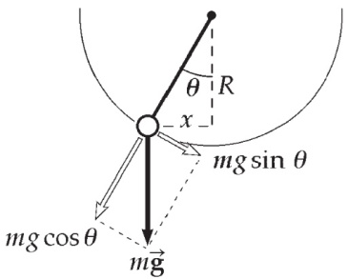

ANS. FIG. P15.18

For small displacements,

 and 

Since the restoring force is proportional to the displacement from equilibrium, the   
motion is simple harmonic motion.

Comparing to  shows



**P15.19** *f* = 0.450 Hz, *d* = 0.350 m, and *m* = 2.20 kg. Now,

****

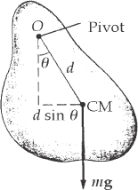

ANS. FIG. P15.19

Solving for the moment of inertia, we obtain



**P15.20** Please see ANS. FIG. P15.19. For a physical pendulum,



**P15.21** Using the simple harmonic motion model:



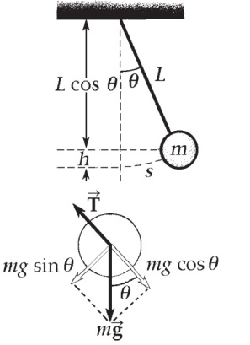

ANS. FIG. P15.21

(a) 

(b) For simple harmonic motion, the maximum acceleration



which is equal to the maximum tangential acceleration, occurs at the extreme ends of the swing:



(c) The maximum restoring force causes the maximum acceleration:



(d) (a) Applying energy conservation to the isolated pendulum-Earth system:



and 

then



**P15.22** (a) The parallel-axis theorem gives 

so 

(b) When *d* is very large  gets large.

When *d* is very small  gets large.

So there must be a minimum, found by



This requires



or 

**P15.23** The period of oscillation for the watch balance wheel is *T* = 0.250 s. Modeling the 20.0-g mass as a particle, we find the moment of inertia from *I* = *mr*2.

(a) 

(b) To find the torsion constant, we use Equation 15.29 for the motion of a torsional pendulum,



where



Solving for the torsion constant gives



**Section 15.6 Damped Oscillations**

**P15.24** The total energy is 

Taking the time derivative gives 

Then, substituting from Equation 15.31,  gives



Thus, 

We have proved that the mechanical energy of a damped oscillator is always decreasing.

**P15.25** To show that 

is a solution of  **[1]**

where  and *b*2 < 4*mk* so that *ω* is real, **[2]**

we take  and compute **[3]**

 **[4]**



 **[5]**

We substitute [3] and [4] into the left side of [1], and [5] into the right side of [1]:



We then compare the coefficients of the  and the  terms.

The cosine term is



and the sine term is



Since the coefficients are equal,  is a solution of the equation.

**Section 15.7 Forced Oscillations**

**P15.26** The pendulum is resonating with the beeper. The beeper must vibrate at the frequency of a simple pendulum of frequency 1.50 Hz:



**P15.27** We are given *F* = 3.00 sin (2*π t*), *k* = 20.0 N/m, and *m* = 2.00 kg.

(a) 

(b) From *F* = 3.00 sin (2*π t*), the angular frequency of the force is



(c) From equation 15.36, the amplitude *A* of a driven oscillator, with *b* = 0, gives



**P15.28** We start with Equation 15.34,  **[1]**

Equation 15.35 gives the solution to this equation as

 **[2]**

differentiating,

 **[3]**

and differentiating again,

 **[4]**

Substituting [2] and [4] into [1]:



Solving for the amplitude:



These will be equal, provided only that *φ* must be +90º and



Thus, , where 

**\*P15.29 Conceptualize** Look carefully at Figure P15.29. By placing the probe on the disk, you have increased the overall moment of inertia of the oscillating system. This will cause a decrease in the period of the torsional pendulum.

**Categorize** The system is categorized as a torsional pendulum, as discussed in Section 15.5.

**Analyze** (a) The period of oscillation of the empty disk is given by Equation 15.30:

 (1)

where ** is the torsion constant of the wire. When the probe is placed on the disk, the moment of inertia of the probe is added to that of the disk. Therefore, the new period of oscillation is

 (2)

where ** is the same because it is determined only by the support wire. Divide Equation (2) by Equation (1):

 (3)

Solve Equation (3) for the moment of inertia of the probe:

 (4)

Finally, substitute for the moment of inertia of the empty disk:

 (5)

Substitute numerical values:



(b) The role of *I*disk in the equations above is that of the moment of inertia of the unloaded oscillator. Therefore, it can be considered as *I*empty, which would include the moment of inertia of the frame. Everything proceeds in the same way until Equation (4), which is written

 (6)

The difficulty arises when evaluating *I*empty. In part (a), we calculated this moment of inertia as that of the disk. If we were to include some additional moment of inertia of the frame, then



Therefore, the corrected moment of inertia using Equation (6) would give a value higher than that from Equation (5). Therefore, the value you calculated in part (a) is *too low*.

**Finalize** What experiment could you perform to find the moment of inertia of the frame?

Answer: (a) 0.349 kg · m2 (b) too low

**\*P15.30 Conceptualize** Figure 20.5c shows the atoms vibrating back and forth and Figure 7.23 shows the potential energy function, whose derivative is given in Example 7.9:

 (1)

We can relate this to the force between molecules using Equation 7.29:

 (2)

Now, let the separation distance be the equilibrium separation distance *r*eq plus a small deviation *x*, where *x* << *r*eq:



Now, in Appendix Section B.5, we find a series approximation: For very small *x*, (1 + *x*)*n* ≈ 1 + *nx*. Use this approximation on the two parentheses in Equation (3):

 (4)

In Example 7.9, we also see that the equilibrium separation distance is given by *r*eq = (2)1/6**. Solve this equation for **:

 (5)

Substitute Equation (5) into Equation (4):



Equation (5) is of the form of Hooke’s law *F* = –*kx*, so the factor in the parentheses is the effective spring constant for small oscillations. Your supervisor asked for the spring constant in terms of the parameters ** and *e*, so we need to make one more substitution:

 (6)

Therefore, the effective spring constant is

 (7)

**Finalize** This is the form of the effective spring constant requested by your supervisor. Using the vales for the parameters ** and *e* given in Example 7.9, we can evaluate the effective spring constant numerically and check to make sure it has the correct units:



The units do work out correctly for a spring constant!

*Answer:* 

**Additional Problems**

P15.31 From *a = – ω*2*x*, the maximum acceleration is given by *a*max *= ω*2*A*. Then 108 cm/s2 = *ω*2 (12.0 cm), giving *ω* = 3.00 rad/s.

(a) 

(b) 

(c) 

(d) 

(e) From  we obtain



(f) 

**P15.32** (a) Consider the first process of spring compression. It continues as long as glider 1 is moving faster than glider 2. The spring instantaneously has maximum compression when both gliders are moving with the same speed *va*.

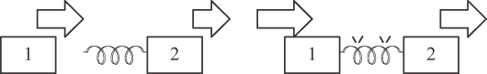

ANS. FIG. P15.32 (a)

Momentum conservation then gives





(b) From energy conservation, we have





(c) 

(d) 

**P15.33** (a) The amplitude is the magnitude of the maximum displacement from equilibrium (at *x* = 0). Thus, 

(b) The period is the time for one full cycle of the motion. Therefore, 

(c) The angular frequency is .

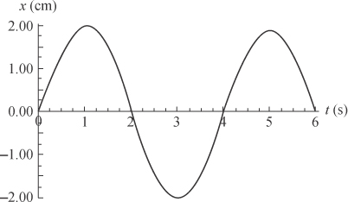

ANS. FIG. P15.33

(d) The maximum speed is



(e) The maximum acceleration is



(f) The general equation for position as a function of time for an object undergoing simple harmonic motion with *x* = 0 when *t* = 0 and *x* increasing positively is  For this oscillator, this becomes



**P15.34** (a) From *a = –ω* 2*x*, the maximum acceleration is given by *a*max *= ω* 2*A*. As *A* increases, the maximum acceleration increases. When it becomes greater than the free-fall acceleration, the rock will no longer stay in contact with the vibrating ground, but lag behind as the ground moves down with greater acceleration. We have then



(b) 

**P15.35** We draw a free-body diagram of the pendulum in ANS. FIG. P15.35. The force  exerted by the hinge causes no torque about the axis of rotation.

 and 



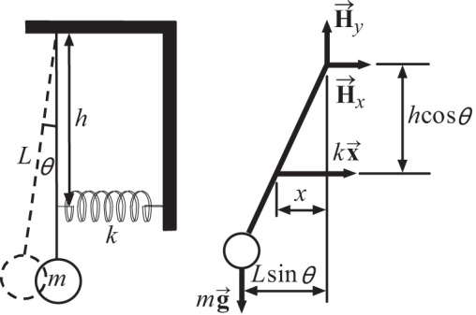

**ANS. FIG. P15.35**

For small-amplitude vibrations, use the approximations:   and 

Therefore,



**P15.36** (a) The period of the swinging rod is

**:Art:Chapter 12 art:P12_45a.eps** 

ANS. FIG. P15.36

The time for one half a cycle is .   
The distance traveled in this time is the stride length  so the speed is



(b) We use the more precise expression



(c) With



dividing gives



**P15.37** As it passes through equilibrium, the 4.00-kg object has speed



In the completely inelastic collision, momentum of the two-object system is conserved. So the new 10.0-kg object starts its oscillation with a new maximum speed given by



(a) The system consisting of the two objects, the spring, and the Earth, is isolated, so mechanical energy is conserved. The new amplitude is given by





(b) The old period was 

The new period is 

The period of the system has changed by a factor of



(c) The old energy was 

The new mechanical energy is 

The energy has 

(d) 

**P15.38** Suppose a 100-kg biker compresses the suspension 2.00 cm.

Then,



If total mass of motorcycle and biker is 500 kg, the frequency of free vibration is





Assuming a speed of 20.0 m/s, we find these ridges are separated by



In addition to this vibration mode of bouncing up and down as one unit, the motorcycle can also vibrate at higher frequencies by rocking back and forth between front and rear wheels, by having just the front wheel bounce inside its fork, or by doing other things. Other spacing of bumps will excite all of these other resonances.

**P15.39** (a) 

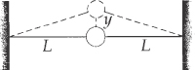

ANS. FIG. P15.39

where 

Therefore, for a small displacement,

 and 

(b) The total force exerted on the ball is opposite in direction and proportional to its displacement from equilibrium, so the ball moves with simple harmonic motion. For a spring system,

 becomes here 

Therefore, the effective spring constant is  and



**P15.40**  (a) We require 

or 

or 

which gives 

The spring constant is irrelevant.

(b) We can evaluate the energy at successive turning points, where

 and the energy is 

We require 

or 

which gives



(c) From  the fractional rate of change of energy over time is



which gives 

which is twice as fast as the fractional rate of change in amplitude.

**P15.41** (a) Let  represent the length below water at equilibrium and *M* the tube’s mass:



Now with any excursion *x* from equilibrium



Subtracting the equilibrium equation gives





(b) For SHM,  the coefficient of *x* is the square of the angular frequency:



**P15.42** (a) The block moves with the board in what we take as the positive *x* direction, stretching the spring until the spring force –*kx* is equal in magnitude to the maximum force of static friction:



This occurs at 

(b) Since *v* is small, the block is nearly at the rest at this break point. It starts almost immediately to move back to the left, the forces on it being –*kx* and  While it is sliding the net force exerted on it can be written as



where *xrel* is the excursion of the block away from the point .

Conclusion: the block goes into simple harmonic motion centered about the equilibrium position where the spring is stretched by 

(c) The graph of the motion looks as shown in ANS. FIG. P15.42(c):

**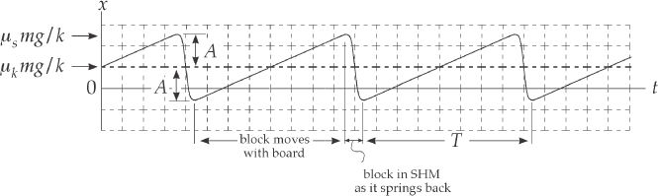**

**ANS. FIG. P15.42 (c)**

(d) The amplitude of its motion is its original displacement,  because the block has been pulled out to , then it goes into simple harmonic motion centered about .

It first comes to rest at spring extension 

Almost immediately at this point it latches onto the slowly-moving board to move with the board. The board exerts a force of static friction on the block, and the cycle continues.

(e) The time during each cycle when the block is moving with the board is  The time for which the block is springing back is one half a cycle of simple harmonic motion,  (because the block slides from +*A* to –*A* during its SHM). We ignore the times at the end points of the motion when the speed of the block changes from *v* to 0 and from 0 to *v*. Since *v* is small compared to  these times are negligible. Then the period is



**\*P15.43 Conceptualize** As the roller moves back and forth, it is both translating and rotating, so we will need to combine our understanding of translational motion and rotational motion. Keep in mind that if each portion of ground has to be rolled ten times, then we need to find the total time interval for *five* oscillations.

**Categorize** The system can be modeled as a combination of a *particle in simple harmonic motion* (the center of mass of the roller) and a *rigid object in pure rolling motion.*

**Analyze** Let us write the energy of the system of the roller and the spring for an arbitrary position *x*. The value of this energy should remain constant in the absence of rolling friction:

 (1)

where *v* is the speed of the center of mass of the roller and *x* is the position of the center of mass relative to the equilibrium position *x* = 0 at which the spring is neither extended nor compressed. Because the roller is in the shape of a cylinder, we can use Table 10.2 to substitute for the moment of inertia, and Equation 10.28 to substitute for the angular speed:

 (2)

Take the derivative of this equation with respect to time, recognizing that the derivative is equal to zero because the total energy of the system is a constant:



Rearrange Equation (3) and replace *dx*/*dt* with *v*:

 (4)

Now recognize that *dv*/*dt* is the acceleration *a* and solve for *a*:

 (5)

Now compare Equation (5) to Equation 15.2. This allows us to identify the angular frequency of the roller system using Equation 15.9:

 (6)

Incorporating Equation 15.13, we have the period of the roller system:

 (7)

To roll the ground ten times, the roller must make five oscillations, so the time interval to relax is



Substitute numerical values:



**Finalize** Is this really a better scheme than simply rolling the roller? Every 13.0 s, you must jump up, remove the post from the ground, fix it in a new location, pull out the roller, and then sit down for a few more seconds. You decide. One more thing: What’s your father going to think about all those post holes all over the yard?

*Answer:* 13.0 s

**P15.44** From the oscillator information, find the natural frequency of the oscillator:



From the measurement information, find the value of *b*/2*m*:



Solving,





**P15.45** (a) When the mass is displaced a distance *x* from equilibrium, spring 1 is stretched a distance *x*1 and spring 2 is stretched a distance *x*2.

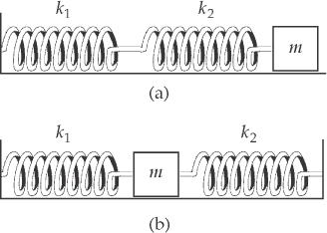

ANS. FIG. P15.45

By Newton’s third law, we expect



When this is combined with the requirement that



we find 

The force on either spring is given by 

where *a* is the acceleration of the mass *m*.

This is in the form 

and 

(b) In this case each spring is distorted by the distance *x* which the mass is displaced. Therefore, the restoring force is

 and 

so that 

P15.46 The free-body diagram in ANS. FIG. P15.46 shows the forces acting on the balloon when it is displaced distance *s = Lθ* along the circular arc it follows. The net force tangential to this path is



For small angles, 

Also, 

and the buoyant force is  Thus, the net restoring force acting on the balloon is



**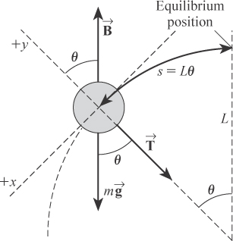**

**ANS. FIG. P15.46**

Observe that this is in the form of Hooke’s law,  with



Thus, the motion will be simple harmonic and the period is given by



This yields



**P15.47** (a) 

We have at, *t* = 0, 

This requires  so 



Numerically we have 

and 

So , where *x* is in meters and *t* in seconds.

(b) Using  we require 

which implies 

which gives 

(c) The particle’s position is given by 

The particle is at *x* = 0 when

 

At *t* = 0, the particle is at the origin, but moving to the left. The next time the particle is at the origin is when 10*t* = *π* when it is moving to the right.

The particle is first at *x* = 1.00 m when 

So then, 

The minimum time required for the particle to move from *x* = 0 to *x* = 1.00 m is



(d) 

**Challenge Problems**

**P15.48** (a) 

Thus, 

where 

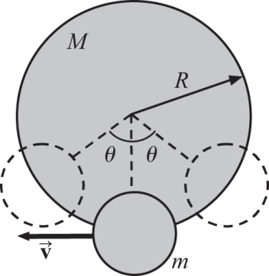

ANS. FIG. P15.48

Therefore,  but



and 

Substituting, we find



and  so



(b) 

Substituting  and solving for *d*CM gives



The period is then



**P15.49** (a) Note that as the spring passes through the vertical position, the object is moving in a circular arc of radius *L* − *yf* , where the *y* coordinate of the object at this point must be negative (*yf* < 0). When the object is at *yf* , the spring is stretched *x = yf – L*. At position *yf* , the spring is stretched and exerting an upward tension force of magnitude greater than the object’s weight. This is necessary so the object experiences a net force toward the pivot to supply the needed centripetal acceleration in this position. This is summarized by Newton’s second law applied to the object at this point, stating (remember, *yf* is negative)

 **[1]**

The system is isolated, so conservation of energy requires that



or



reducing to

 [2]

From equation [1], observe that . Substituting this into equation [2] gives



After expanding and regrouping terms, this becomes



which is a quadratic equation , with





and



Applying the quadratic formula, keeping only the negative solution [see the discussion in part (a)], and suppressing units, gives



or 

(b) Because the length of this pendulum varies and is longer throughout its motion than a simple pendulum of length *L*,  than that of a simple pendulum.

**P15.50** The time interval for your competitor’s package to arrive is half of the orbital period found from Kepler’s third law, Equation 13.11:



Now, consider your proposal. The force on the package at an arbitrary position *r* is



This force is of the form of Hooke’s law! The “spring constant” for this motion is



Because the force on the package is a Hooke’s-law force, the package will oscillate between opposite points on the Earth in simple harmonic motion. To deliver the package to the other side of the Earth, someone must grab the package before it begins its return journey. The time interval for the package to travel to the other side of the Earth is half of a period of oscillation:





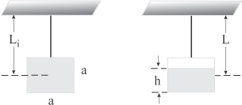**P15.51** (a) The period of the pendulum is   
given by

**ANS. FIG. P15.51**



and changes as

 **[1]**

We need to find *L*(*t*) and . From the diagram in ANS. FIG. P15.51 (a),

 and 

But . Therefore,

 **[2]**

Also,

 **[3]**

Substituting equations [2] and [3] into [1] gives:



Integrating, we get



(b) When the liquid is gone, the CM of the bob is suddenly again at the center of the cube. We had ignored the mass of the cube up until now since it was small compared to the mass of the liquid. Thus, once the liquid is gone, *L* = *Li*.



|  |
| --- |
| **ANSWERS TO QUICK-QUIZZES** |

**1.** (d)

**2.** (f)

**3.** (a)

**4.** (b)

**5.** (c)

**6. (i)** (a) **(ii)** (a)

|  |
| --- |
| **ANSWERS TO EVEN-NUMBERED PROBLEMS** |

**P15.2** (a) 18.8 m/s; (b) 7.11 km/s2

**P15.4** 40.9 N/m

**P15.6** (a) motion is periodic; (b) 1.81 s; (c) The motion is not simple harmonic. The net force acting on the ball is a constant given by F = −mg (except when it is in contact with the ground), which is not in the form of Hooke’s law.

**P15.8** (a) See P15.8 (a) for complete solution; (b) See P15.8 (b) for complete solution

**P15.10** 2.23 m/s

**P15.12** (a) *E* increases by a factor of 4; (b) *v*max is doubled; (c) *a*max also doubles; (d) the period is unchanged.

**P15.14** (a) Particle under constant acceleration; (b) 1.50 s; (c) isolated;   
(d) 73.4 N/m; (e) 19.7 m below the bridge; (f) 1.06 rad/s; (g) +2.01 s;   
(h) 3.50 s

**P15.16** (a) The motion is simple harmonic. (b) 0.628 s (c) 1.00 kg (d) 0.800 m/s

**P15.18 **

**P15.20** 

**P15.22** (a)  (b) 

**P15.24 **

**P15.26** 11.0 cm

**P15.28** See P15.28 for complete solution.

**P15.30** 

**P15.32** (a) 0.368 m/s; (b) 3.51 cm; (c) 40.6 mJ; (d) 27.7 mJ

**P15.34** (a) 4.31 cm; (b) When the rock is on the point of lifting off, the surrounding water is also barely in free fall. No pressure gradient exists in the water, so no buoyant force acts on the rock. The effect of the surrounding water disappears at that instant.

**P15.36** (a) See P15.36 (a) for complete solution; (b) 1.04 m/s; (c) 3.40 m

**P15.38** If he encounters washboard bumps at the same frequency as the free vibration, resonance will make the motorcycle bounce a lot. It may bounce so much as to interfere with the rider’s control of the machine; ~101 m.

**P15.40** (a) 5.20 s; (b) 2.60 s; (c) 

**P15.42** See P15.42 for complete solution.

**P15.44** If the damping constant is doubled, b/2m = 120 s−1. In this case, however,  and the system is overdamped. Your design objective is not met because the system does not oscillate.

**P15.46** (b) 1.46 s

**P15.48** (a)  (b) 

**P15.50** This is exactly the same time interval as for your competitor, so you have no advantage! In fact, you have the disadvantage of the initial capital outlay to bore through the entire Earth!